

**OPERATION**

**RESEARCH**

**Lab file**

Submitted to:

Dr. LN Das

Department of applied mathematics

Submitted by:

Ashish Gupta

2K16/MC/023

**Department of Applied Mathematics**

**Delhi Technological University**

INDEX

|  |  |  |  |
| --- | --- | --- | --- |
| **S. No.** | **Topic** | **Date** | **Signature** |
| 1 | Solve maximization problem by using the simplex method |  |  |
| 2 | Solve problem by using the Big M method |  |  |
| 3 | Discussing sensitivity analysis on problems using tora |  |  |
| 4 | Solve problem by using the two phase method |  |  |
| 5 | Solve problem by using the Dual Simplex method |  |  |
|  |  |  |  |
|  |  |  |  |
|  |  |  |  |
|  |  |  |  |

Program 1: Solve maximization problem by the simplex method

***Problem 1:***

*Objective function: z = 3x1 + 2x2*

*Constraints:-*

*x1 +2x2 <=4*

*3x2 + 2x2 <=14*

*x1 - x2 <= 3*

*x1>=0 x2>=0*

***OUPUT***

**Optimal solution**:

X1 = 4

X2 = 1

**Objective value**:

= 12+2 = 14

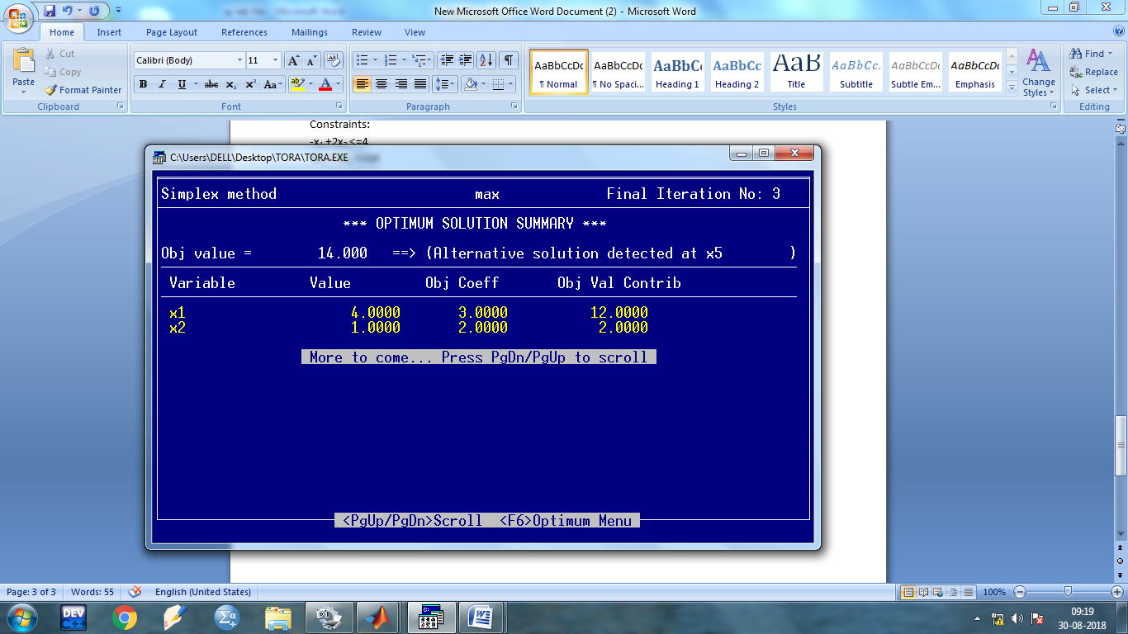

***Problem 2:***

*Objective function: z = 5x1 + 3x2 + 1x3*

*Constraints:-*

*2x1 + 1x2 + 1x3 =3*

*-1x2 + 0x2 + 2x3 = 4*

*x1>=0, x2>=0, x3>=0*

***OUPUT***

**Optimal solution**:

X1 = 0

X2 = 1

X3 =2

**Objective value**:

= 0+2+3 = 5

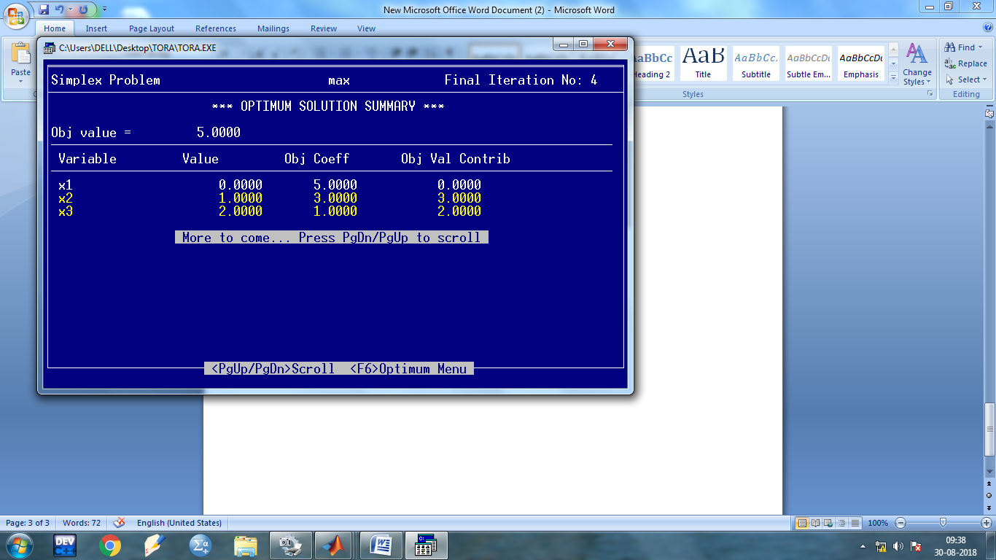

***Problem 3:***

*Objective function: z = 5x1 - 3x2 + 4x3*

*Constraints:-*

*1x1 - 1x2 + 0x3 <=1*

*-3x2 + 2x2 + 2x3 <= 1*

*4x1 + 0x2 - 1x3 =1*

*x1, x2>=0, x3>=0*

***OUPUT***

**Optimal solution**:

X1 = 0.6

X2 = 0.00

X3 =1.4

**Objective value**:

= 3+0+5.6 = 8.6

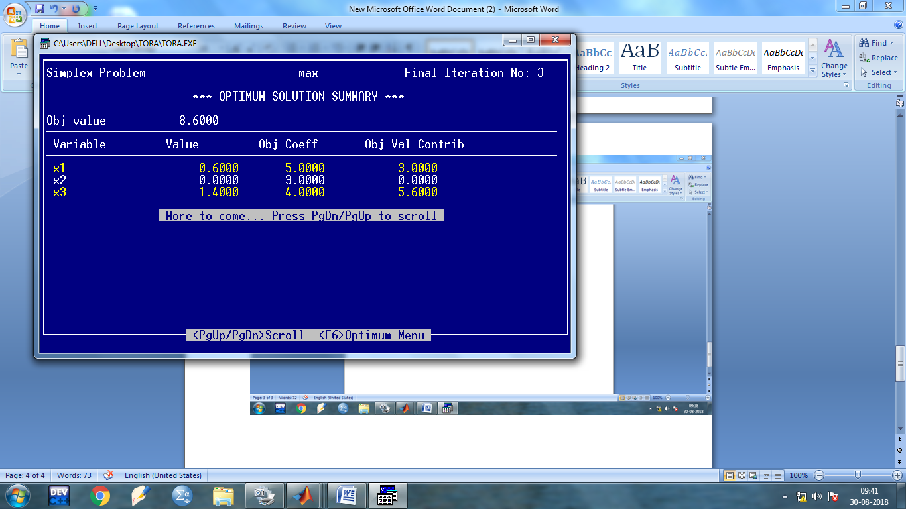

Program 2: Solve problem by using the Big M method

1. **Problem Statement**

***Max. z = 6x1 + 4x2***

*Subjected to*

*2x1 + 3x2<= 30*

*3x1 + 2x2<= 24*

*x1+ x2>= 3*

*x1, x2>= 0*

***OUPUT –***

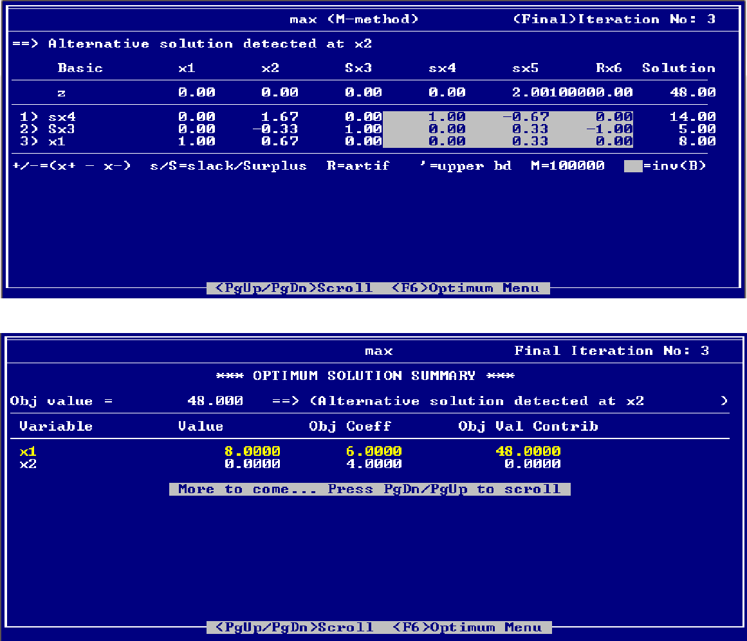

**ii)**

***Maximize Z = 5x1 - 3x2 + 4x3***

*Subject to*

*x1 - x2 <= 1*

*-3x1 + 2x2 + 2x3 <= 1*

*4x1 - x3 = 1*

*x1 is unrestricted in sign*

*x2 , x3 >= 0*

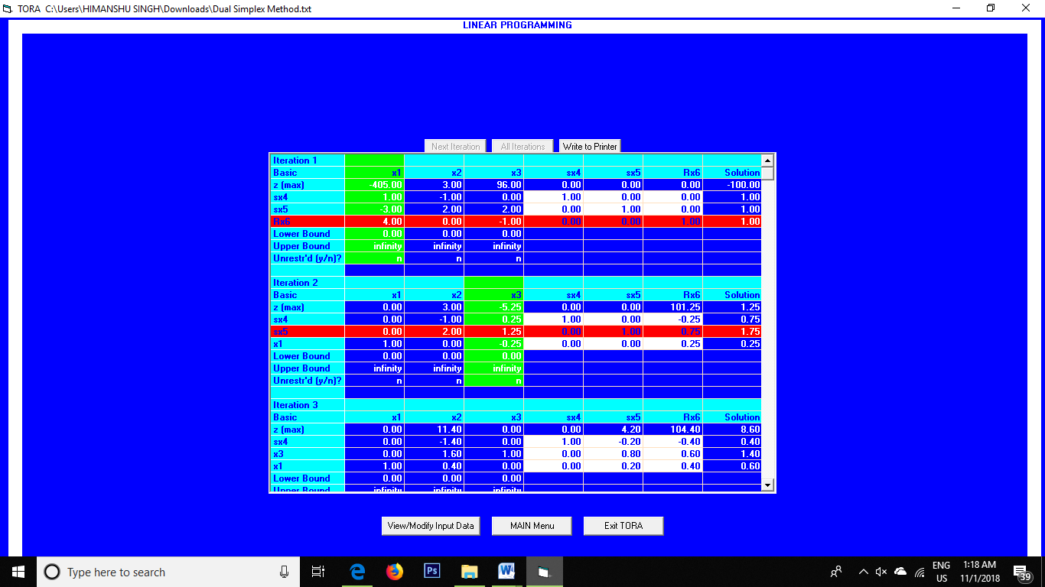

**iii)**

***Max. z = 4x1 + 1x2***

***Subjected to***

*3x1 + 1x2= 3*

*4x1 + 3x2<= 6*

*x1+ 2x2<= 4*

*x1, x2>= 0*

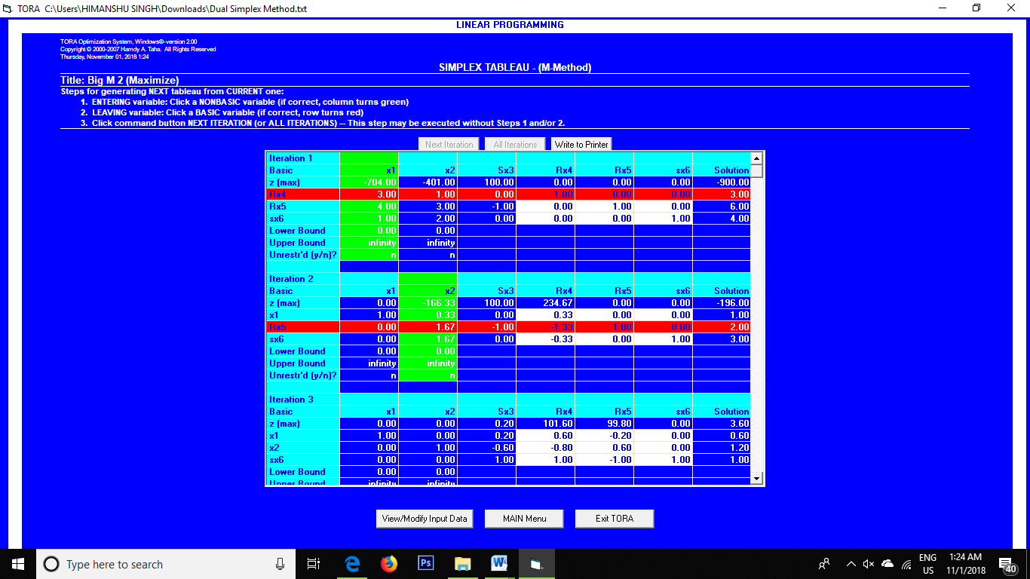

Program 3: Discuss a linear programming solution’s sensitivity analysis by using TORA software in Computer OS.

**Theory of discussion:**

**Sensitivity analysis** involves 'what if?' questions. This technique is used to determine how different values of an independent variable will impact a particular dependent variable under a given set of assumptions. This technique is used within specific boundaries that will depend on one or more input variables, such as the effect that changes in interest rates will have on a bond's price.

Sensitivity analysis **deals** with making individual changes in the co-efficient of the objective function and the right hand sides of the constraints. It is the study of how changes in the co-efficient of a linear programming problem affect the optimal solution.

We can answer questions such as,

1. How will a change in an objective function co-efficient affect the optimal solution?
2. How will a change in a right-hand side value for a constraint affect the optimal solution?

**zmax = 40x1 + 30x2**  
**Subject to constraints**  
4x1 + 5x2≤ 175 ....................(i)  
2x2≤ 50 ....................(ii)  
6x1 + 3x2≤ 150 ....................(iii)  
where x1, x2≥ 0

**The optimal solution is**  
x1 = 12.50  
x2 = 25.00  
zmax = 40 * 12.50 + 30 * 25.00  
 = 1250

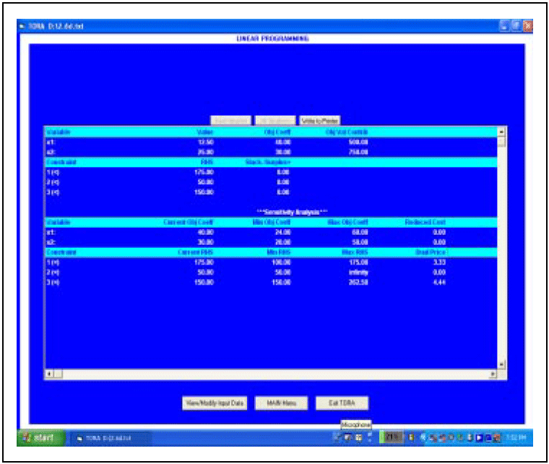

The problem is solved using TORA software and the output screen showing sensitivity analysis is given in Table.

Referring to the current objective co-efficient, if the values of the objective function coefficient decrease by 16 (Min. obj. co-efficient) and increase by 20 (Max. obj. coefficient) there will not be any change in the optimal values of x1 = 12.50 and x2 = 25.00. But there will be a change in the optimal solution, i.e. zmax

***Note:*** This applies only when there is a change in any one of the co-efficients of variables i.e., x1 or x2. Simultaneous changes in values of the co-efficients need to apply for 100 Percent Rule for objective function co-efficients.

For x1, Allowable decrease = Current value - Min. Obj. co-efficient  
= 40 – 24  
= Rs. 16 ------------------ (i)

Allowable increase = Max. Obj. co-efficient – Current value  
= 60 – 40  
= Rs. 20.00 ---------------- (ii)

Similarly, For x2, Allowable decrease = Rs. 10.00 ---------------- (iii)  
Allowable increase = Rs. 20.00 --------------- (iv)

For example, if co-efficient of x1 is increased to 48, then the increase is 48 – 40 = Rs. 8.00. From (ii), the allowable increase is 20, thus the increase in x1 coefficient is 8/20 = 0.40 or 40%.

Similarly,

If co-efficient of x2 is decreased to 27, then the decrease is 30 - 27 = Rs. 3.00.

From (iii), the allowable decrease is 10, thus the decrease in x2 co-efficient is 3/10 = 0.30 or 30%.  
Therefore, the percentage of increase in x1 and the percentage of decrease in x2 is 40 and 30 respectively. i.e. 40% + 30% = 70%

For all the objective function co-efficients that are changed, sum the percentage of the allowable increase and allowable decrease. If the sum of the percentages is less than or equal to 100%, the optimal solution does not change, i.e., x1 and x2 values will not change.

But zmax will change, i.e.,

= 48(12.50) + 27(25)  
= Rs. 1275.00

If the sum of the percentages of increase and decrease is greater than 100%, a different optimal solution exists. A revised problem must be solved in order to determine the new optimal values.

**Problem 2:**

zmax = 40x1 + 30x2 + 50x3

Subject to constraints,

4x1 + 5x2 + 6x3≤ 175 ....................(i)  
2x2 + 1x3≤ 50 ....................(ii)  
6x1 + 3x2 + 3x3≤ 150 ....................(iii)  
where x1, x2, x3≥ 0

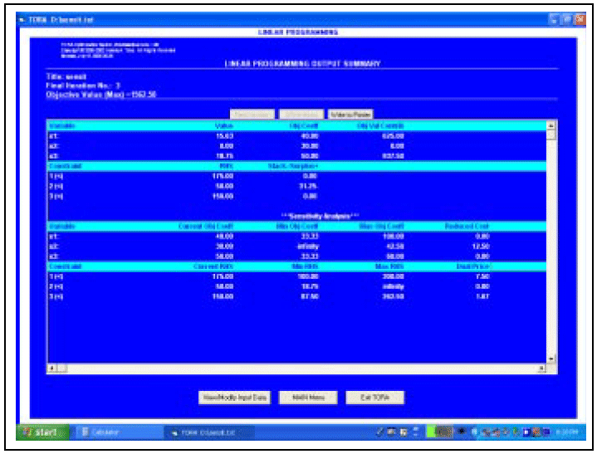

The reduced cost indicates how much the objective function co-efficient for a particular variable would have to improve before that decision function assumes a positive value in the optimal solution.

The reduced cost of Rs.12.50 for decision variable x2 tells us that the profit contribution would have to increase to at least 30 + 12.50 = 42.50 before x3 could assume a positive value in the optimal solution.

Program 4: Solve problem by using the two phase method

1. ***Objective function: z = 3x1 + 2x2 + 1x3***

***Constraints****:-*

*3x1 +1x2 + 1x3 >=3*

*-3x2 + 3x2 + 1x3 >= 6*

*-1x1 -1x2 - 1x3 >=3*

*x1, x2>=0, x3>=0*

***OUTPUT***

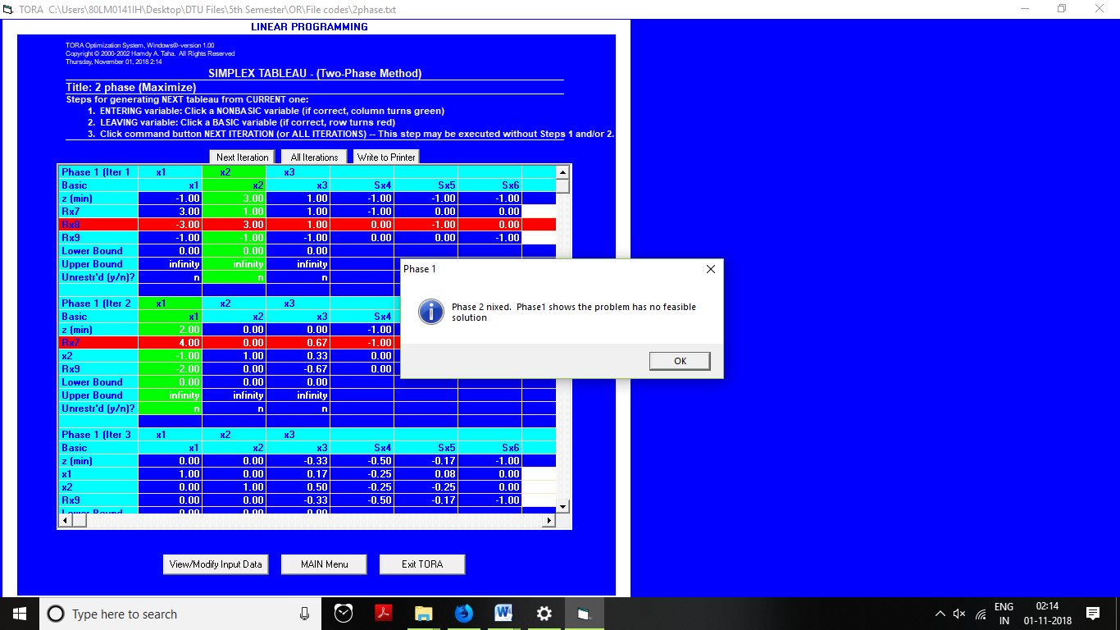

**Solution: No feasible solution**

**ii)**

***Objective function: z = 5x1 + 6x2***

***Constraints:-***

*x1 +1x2 >=2*

*4x2 + 1x2 >=4*

*x1>=0 x2>=0*

**OUPUT**

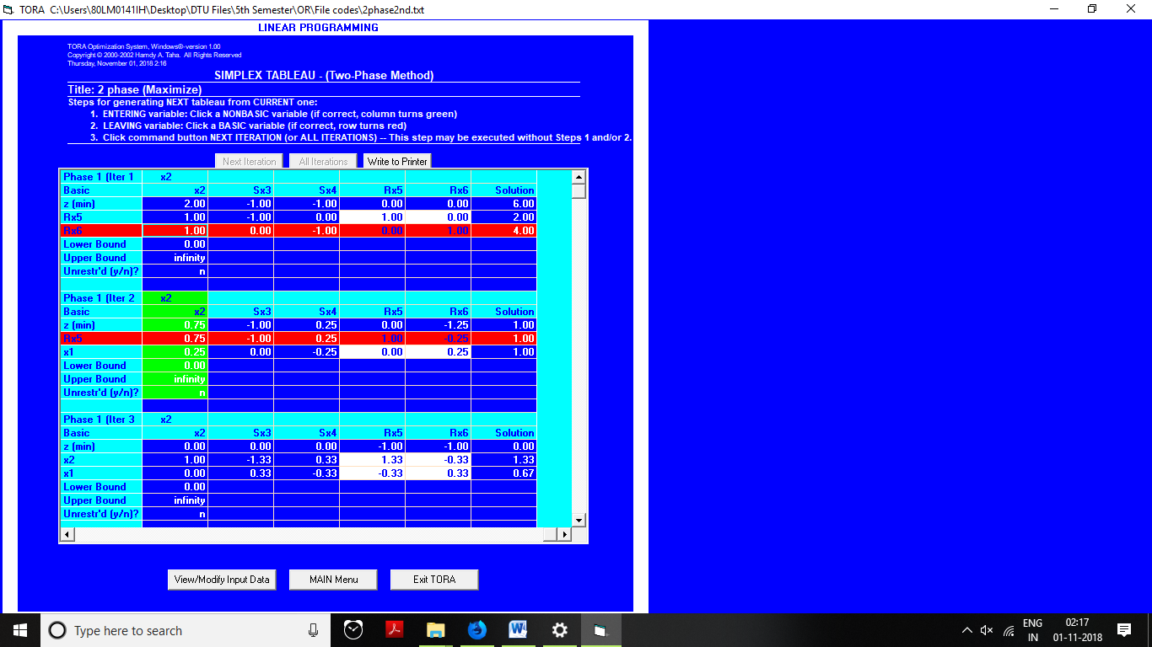

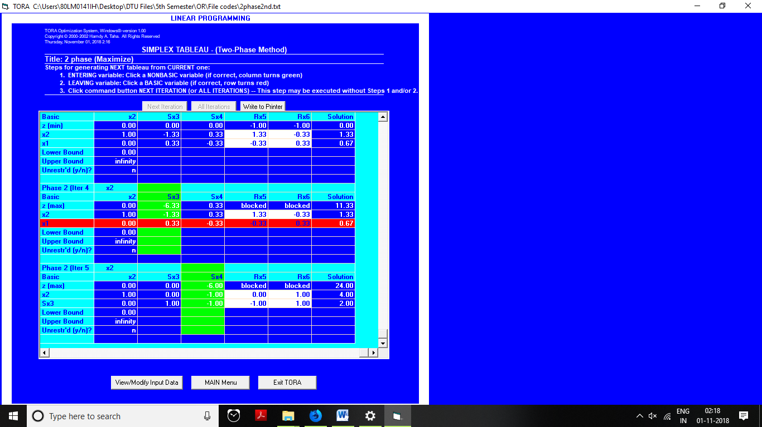

**Output:** Unbounded solution

**iii)**

***Objective function: z = 2x1 + -1x2 + 1x3***

***Constraints:-***

*2x1 +3x2 + -5x3 >=4*

*-1x2 + 9x2 -1x3 >= 3*

*-4x1 + -6x2 - 3x3 >=-8*

*x1, x2>=0, x3>=0*

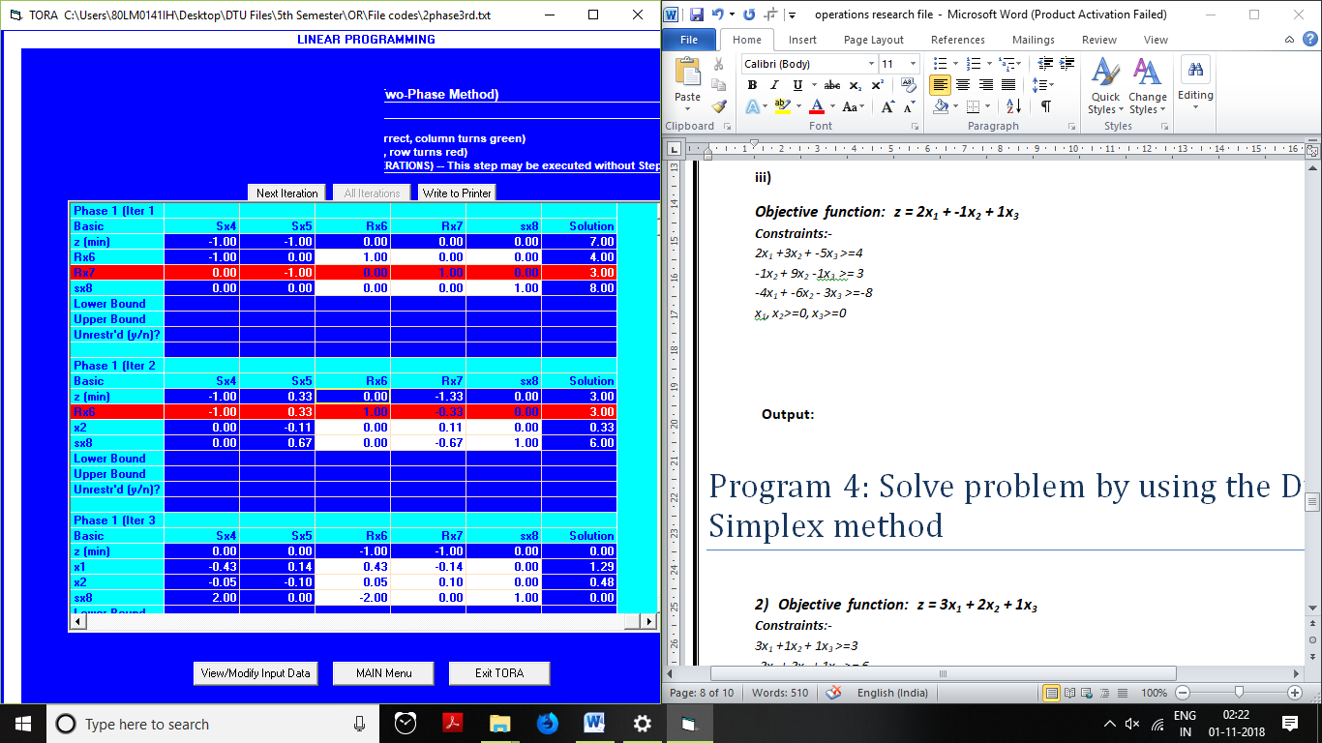

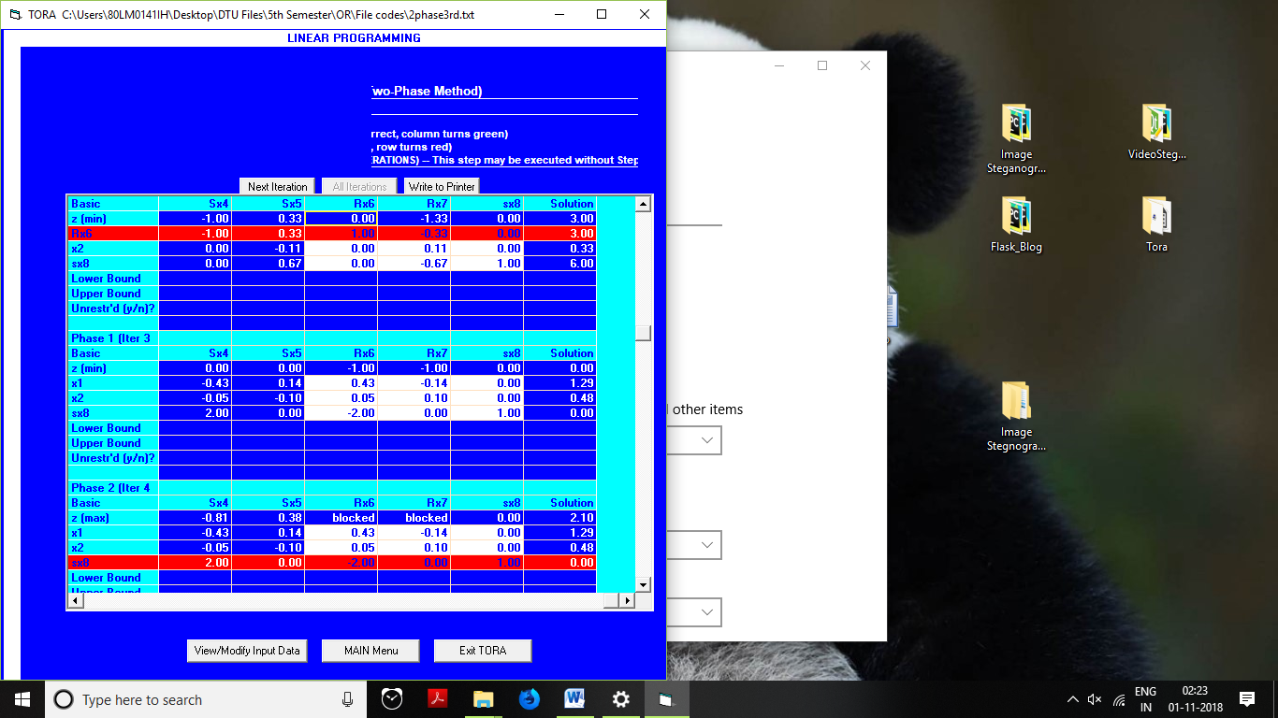

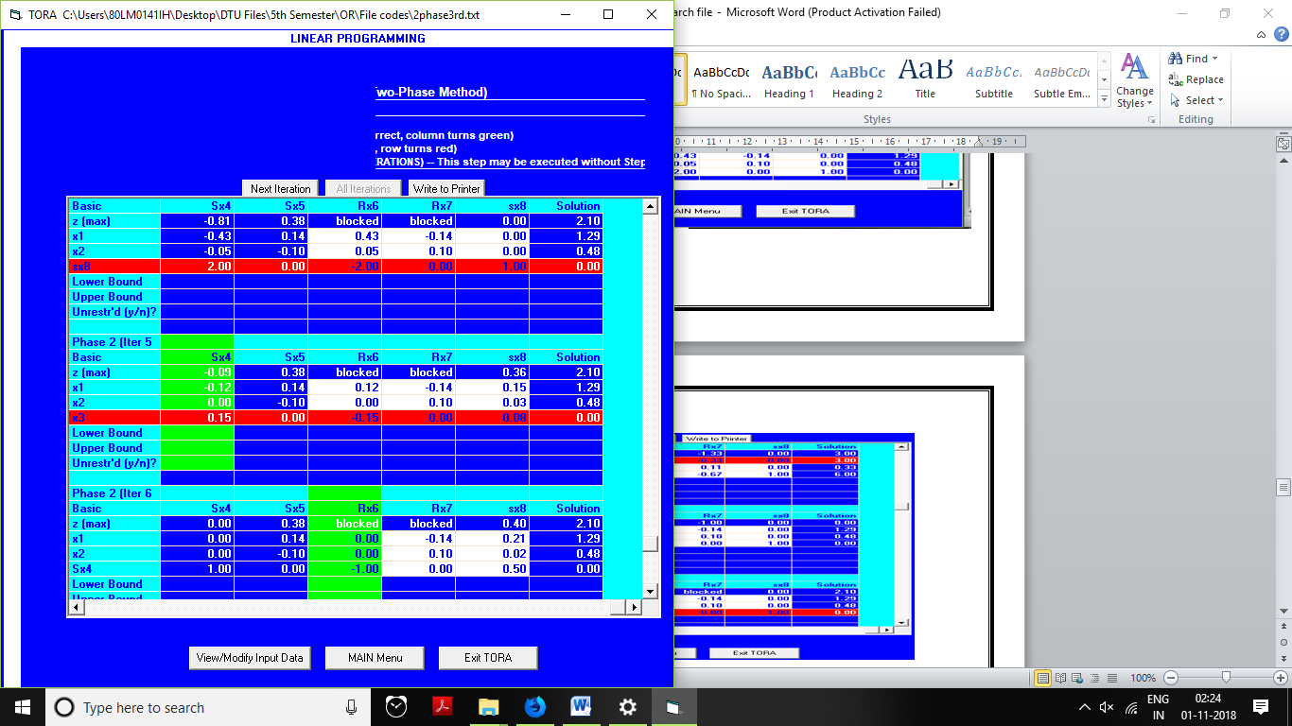

**Output: 2.10 (Optimal at iteration 6)**

Program 5: Solve problem by using the Dual Simplex method

1. ***Objective function: z = 3x1 + 2x2 + 1x3***

***Constraints****:-*

*3x1 +1x2 + 1x3 >=3*

*-3x2 + 3x2 + 1x3 >= 6*

*-1x1 + -1x2 - 1x3 >=-3*

*x1, x2>=0, x3>=0*

***OUTPUT***

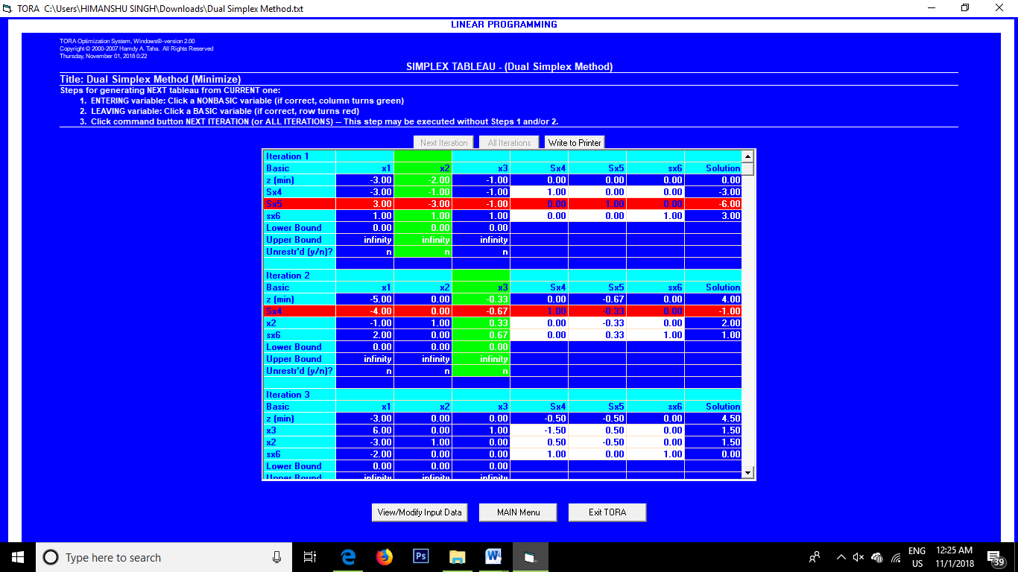

**Solution: Z=4.5, x2=1.5, x3=1.5**

**ii)**

***Objective function: z = 5x1 + 6x2***

***Constraints:-***

*x1 +1x2 >=2*

*4x2 + 1x2 >=4*

*x1>=0 x2>=0*

**OUPUT**

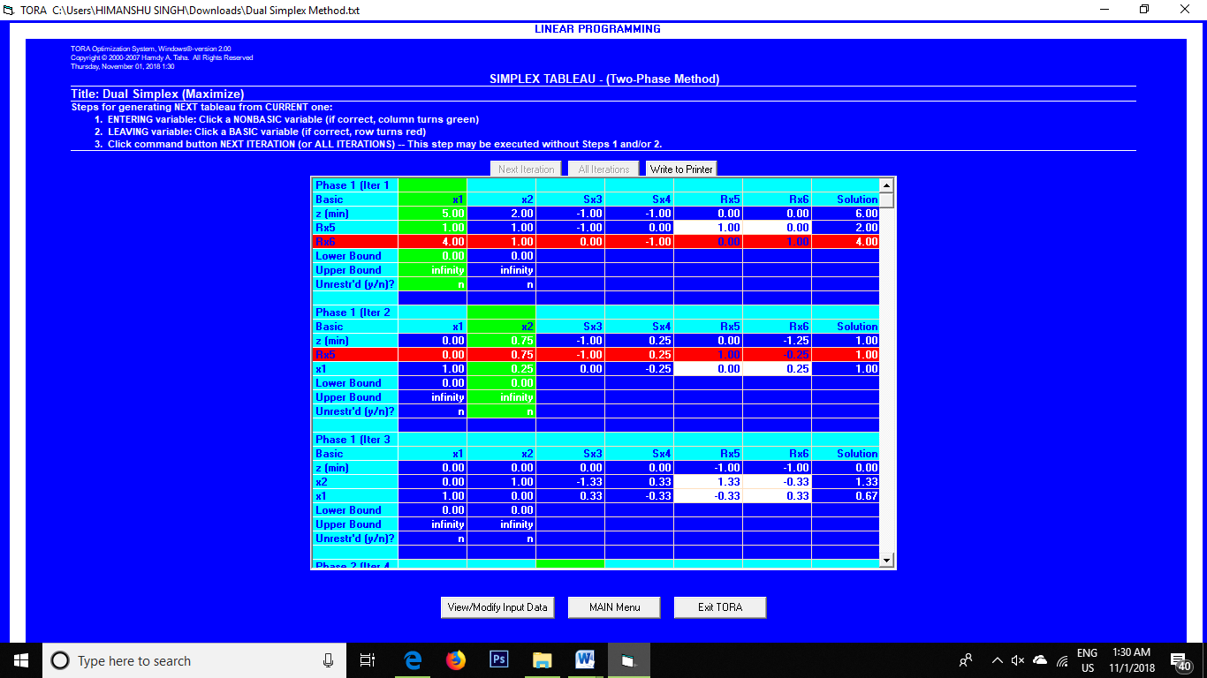

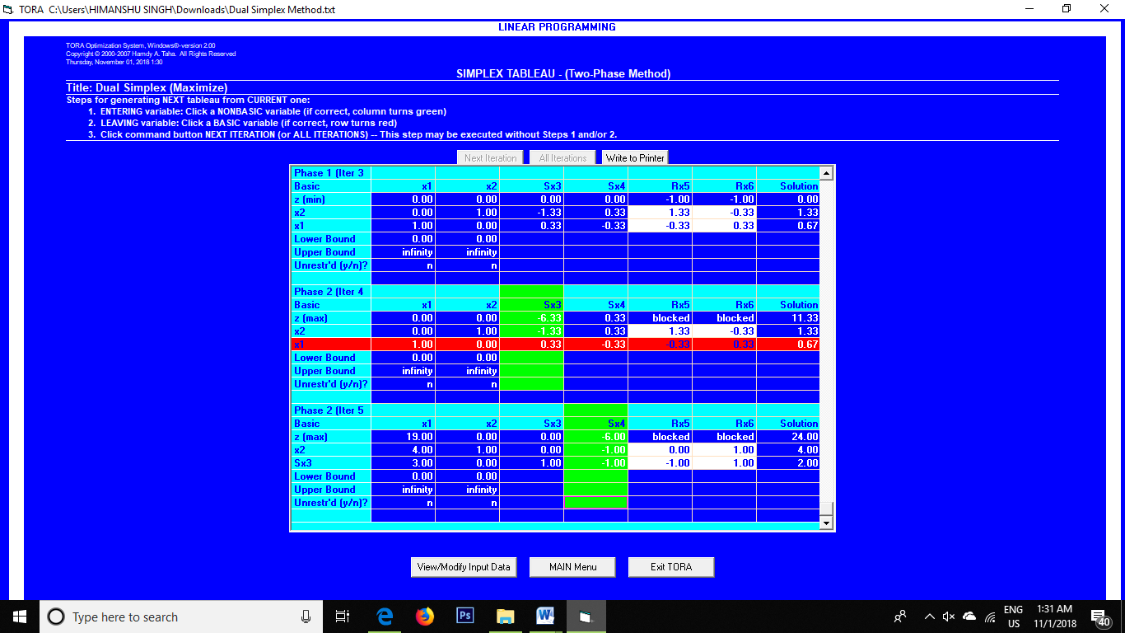

**iii)**

***Objective function: z = 2x1 + -1x2 + 1x3***

***Constraints:-***

*2x1 +3x2 + -5x3 >=4*

*-1x2 + 9x2 -1x3 >= 3*

*-4x1 + -6x2 - 3x3 >=-8*

*x1, x2>=0, x3>=0*

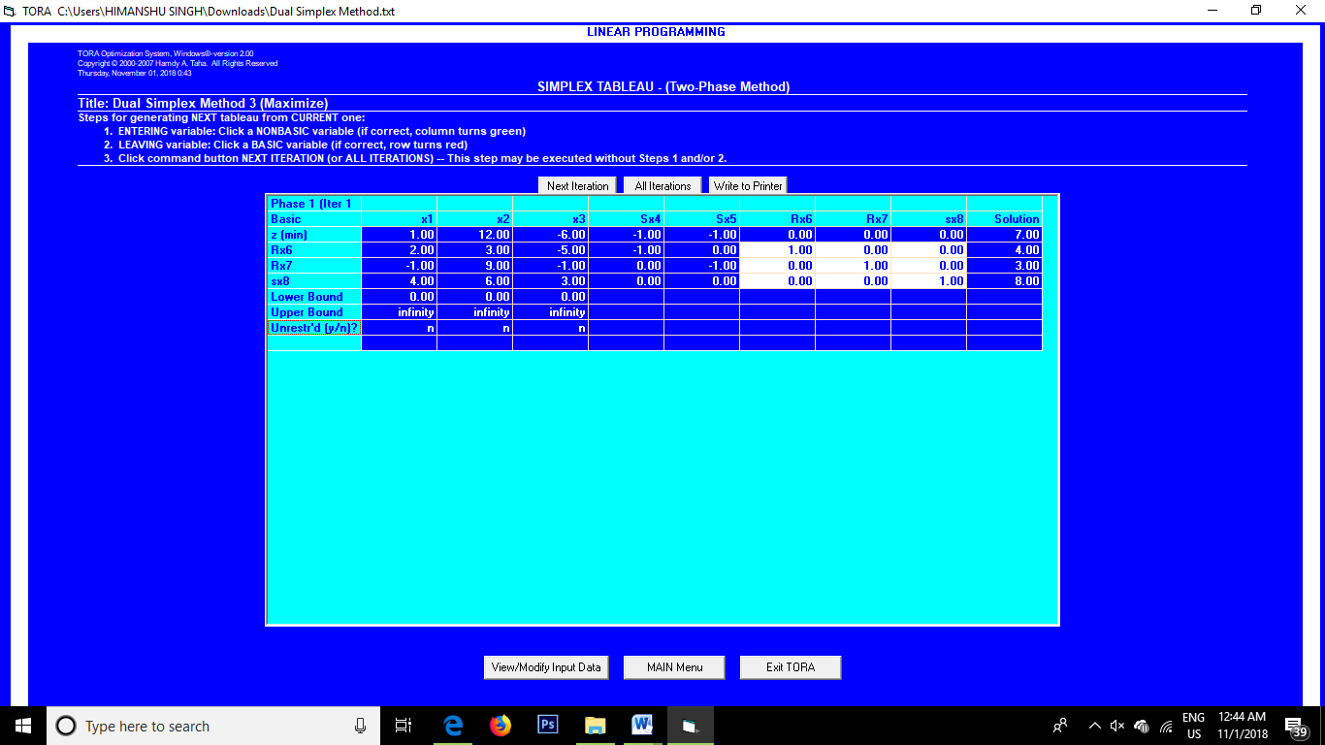

**Output: Objective Function : 7**

Program 6: Solve problem and performing PERT Analysis

***INPUT***

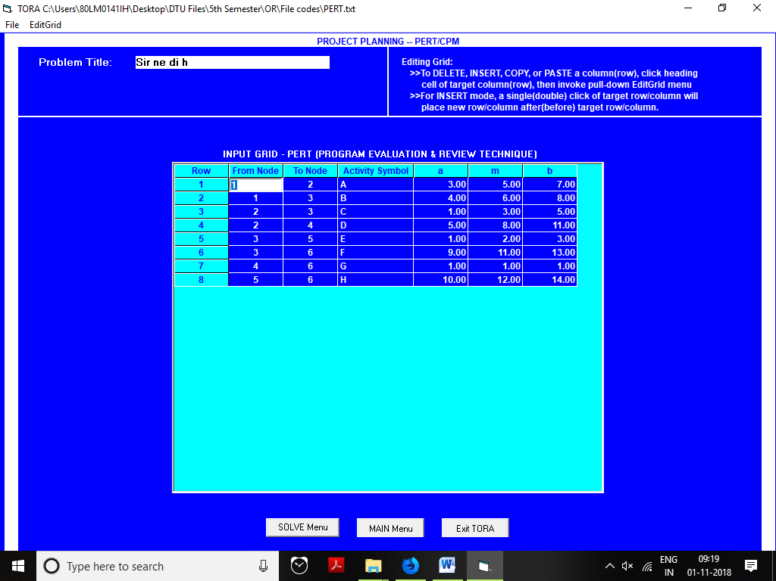

***Output***

